**Introduction to Networking**

* Definition: Networking is the practice of connecting computers and other devices to share resources.
* Purpose: Enables communication, resource sharing (e.g., files, printers), and internet access.
* Types: Wired and wireless networks.
* Importance: Essential for business operations, personal communications, and internet connectivity.

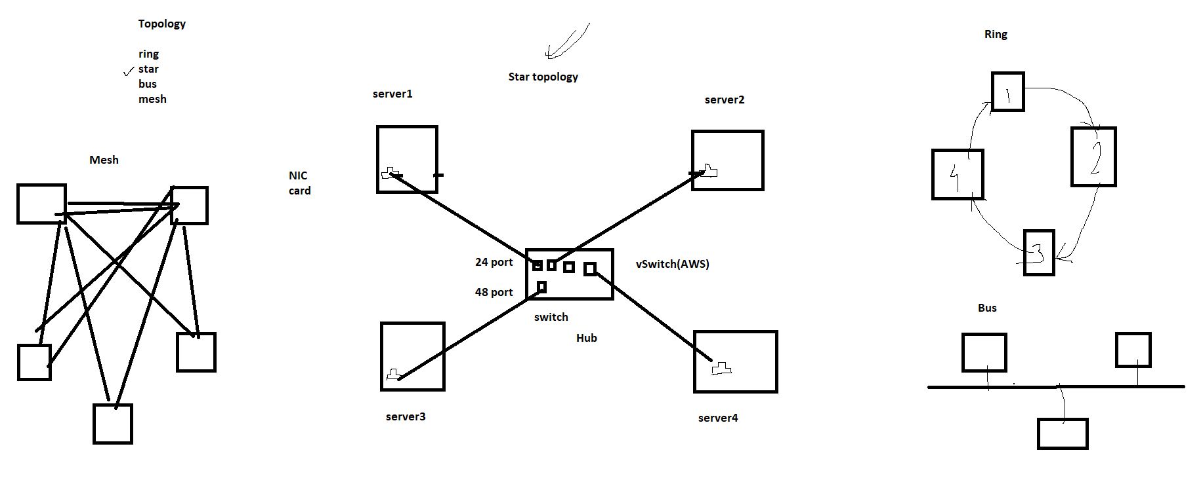

**Components Inside the Network**

* Nodes: Devices like computers, printers, and servers.
* Links: Physical (cables) or wireless connections between nodes.
* Network Interface Cards (NICs): Hardware to connect devices to the network.
* Hubs: Basic devices to connect multiple devices in a network (less common now).
* Repeaters: Devices that amplify signals to extend network range.

**OSI (Open System Interconnection) Model (7 Layers)**

1. **Physical Layer**: Hardware transmission technologies (e.g., cables, switches).
2. **Data Link Layer**: Node-to-node data transfer (e.g., MAC addresses, switches).
3. **Network Layer**: Path determination and logical addressing (e.g., IP addresses, routers).
4. **Transport Layer**: End-to-end communication and error recovery (e.g., TCP, UDP).

**TCP (Transmission Control protocol)** : http(80), https(443), ssh(22), smtp, ftp etc

**UDP(User Datagram protocol)** : dns (53), dhcp, ntp etc

1. **Session Layer**: Manages sessions between applications (e.g., opening, closing connections).
2. **Presentation Layer**: Data translation, encryption, and compression (e.g., SSL/TLS).
3. **Application Layer**: Network services to applications (e.g., HTTP, FTP, SMTP).

**Classification of Networks Based on Geography**

* **PAN (Personal Area Network)**: Small network for personal devices (e.g., Bluetooth).
* **LAN (Local Area Network)**: Network within a single location (e.g., home, office).
* **MAN (Metropolitan Area Network)**: Network across a city or large campus.
* **WAN (Wide Area Network)**: Network over a large geographical area (e.g., the internet).

**Network Devices: Router and Switch**

* **Router**: Directs data packets between different networks, connects LANs to the internet.
* **Switch**: Connects devices within a LAN, uses MAC addresses to forward data to the correct device.

**Home Network Example**

* Typical setup: Modem connected to ISP, router connected to modem, multiple devices connected to the router (wired/wireless).
* Devices: Computers, smartphones, smart TVs, printers.
* Security: Password-protected Wi-Fi, firewall settings.

**Understanding Network and IP**

* **Network**: Interconnected devices sharing resources and data.
* **IP Address**: Unique identifier for a device on a network.
* Types of IP: IPv4 (e.g., 192.168.1.1) and IPv6 (e.g., 2001:0db8::1).
* **Networking :**
* **Basic networking:**

Class full IP

Class less IP

**Class full IP :**

**N(Network) - constant**

**H(Host) - variable**

**class A : 1 - 126**

**class B : 128 - 191**

**class C : 192 - 223**

**xxxxxxxxxxxxxxxxxxxxxxxxxxx**

**class D : 224 - 239**

**class E:  240 - 254**

196.32.25.16

* **class A : 1 - 126        - N . H . H . H**  (254)

                                   255.0.0.0

**/8**

10. 254x254x254 = 1 crore

10.0.0.1

10.0.0.2

10.0.1.1

10.0.1.2

10.254.254.254

* **class B : 128 - 191    - N . N . H . H**

**255.255.0.0**

**/16**

172.16. 254x254 = 65000

172.16.0.1

172.16.0.2

.

.

172.16.0.254

172.16.1.1

-

172.16.1.254

* **class C : 192 - 223    -**

**8   8   8     8**

**N . N . N . H**

**255.255.255.0**

**/24**

192.168.1 x 254 = 254

192.168.1.1

-

-

192.168.1.254

xxxxxx

class D : 224 - 239

class E:  240 - 254

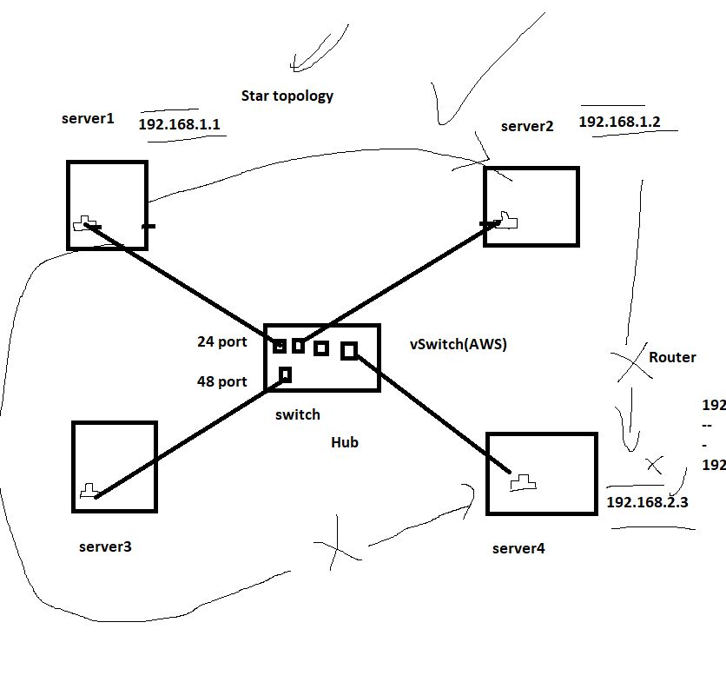

**Public and Private IP**

* **Public IP**: Address assigned to a device accessible from the internet, provided by ISPs.
* **Private IP**: Address used within a private network, not accessible directly from the internet (e.g., 192.168.x.x, 10.x.x.x).

**Networking Commands**

* **ping**: Test connectivity between devices.
* **ipconfig (Windows)/ifconfig (Linux)**: Display network configuration.
* **tracert (Windows)/traceroute (Linux)**: Show path packets take to reach a destination.
* **netstat**: Display active connections and listening ports.

netstat –ntlp

* **nslookup**: Query DNS to find the IP address of a domain.

nslookup [www.google.com](http://www.google.com)

* **Telnet**: To check the port is reachable or not

**telnet** [**www.google.com**](http://www.google.com) **443**